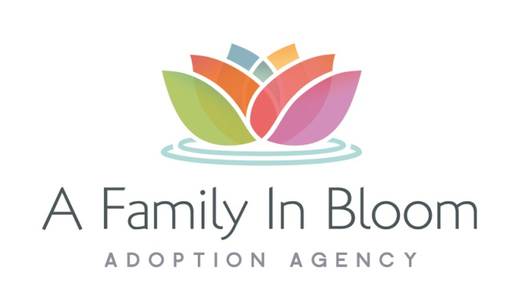

PRELIMINARY APPLICATION FORM

Family Name:___________________________ |  |  |  | Date: _____________________________
Address: __________________________________________________________________

Mailing Address:_____________________________________________________________

Home Phone: __________________________ |  |  |  | Alternate phone #: __________________
Applicant 1 |  |  |  | Applicant 2
Name: _____________________________ ________________________________
Phone: _____________________________ ________________________________
Email: _____________________________ ________________________________
Birth date: ___________________________ ___________________________
Race: ___________________________ ___________________________
Religion: ___________________________ ___________________________
Income: ___________________________ ___________________________

Date of Marriage: | Number of previous marriages for each applicant:
Number of children: _________ |  |  |  | Ages of children: _____________________
Number of adopted children:_________

Do you or your spouse have any current health concerns or history of health issues? ________
If yes, please explain:

Have you or your spouse ever been treated for depression or mental illness?
If yes, please explain:

Have you or your spouse been arrested, charged and/or convicted of any criminal offense?
If yes, please explain:

Have you or your spouse ever been involved with illegal drug use?
If yes, please explain:

Have you had a home study done before?
If yes, provide the name and address of previous home study agency:

Do you have any previous adoption experience? If yes, provide the date.

Have you ever experienced an unsuccessful adoption? If yes, please explain:

What type of child are you interested in adopting?
Boy |  | Girl |  |  | Either
Age:
Siblings? |  | Yes |  |  | No
Waiting child? |  | Yes |  |  | No
Please share your reasons for adoption:

Will your insurance cover the child upon arrival? |  | Yes |  |  | No
Will any pre-existing conditions be covered? |  | Yes |  |  | No
How did you hear about our agency?

STATEMENT OF UNDERSTANDING
To the best of my/our knowledge, the attached information is true.

I/We understand that the application fee of $25.00 is non-refundable, and that it does not
guarantee the receipt of a formal application.
____________________________________ __________________________________
Applicant #1 Signature and Date |  |  | Applicant #2 Signature and Date
In order to receive information about waiting children, please return your application and $25.00 fee to: A Family in Bloom Adoption, 5426 Ptarmigan Circle, Boulder, CO 80301

